IVTECH – LICENSE & BI DASHBOARD WEB APP

Software Development Plan

App Version 1.0.0

Revision History

Date | Doc Version | Author | Status (Created/ Updated/ Reviewed/ Approved/ Verified)
01-03-2025 | 1.0 | Parth Jotangiya | Created

Table of Contents
1. Project Overview 4
1.1 Project Scope and Objectives 4
1.2 Project Deliverables 4
1.3 Assumptions and constraints 4
1.4 Definitions, Acronyms, and Abbreviations 4
1.5 References 4
2. Project Plan 4
2.1 Process tailoring and Documentation Plan 4
2.2 Project Schedule 4
2.3 Resource Plan 4
2.3.1 Roles and responsibilities 4
2.3.2 Resource allocation plan 4
2.3.3 Resource Acquisition plan 4
2.3.4 Training Plan 5
2.4 Quality Assurance Plan 5
2.4.1 Metric Plan 5
2.4.2 Project Review Plan 5
2.4.3 Test Plan 5
2.5 Configuration Plan 6
3. Miscellaneous Plans 6
3.1 Risk Management Plan 6
3.2 Communication Plan 6
3.3 Status Reporting Plan 6
3.4 Escalation plan 7
3.4.1 Internal Escalation 7
3.4.2 External Escalation 7
3.5 Customer Supplied Products (If applicable) 7
3.6 Back Up plan 7
3.7 Close out Plan 7

Project Plan Document

Project Overview

Project Scope and Objectives
- The purpose of this project is to revamp an existing Web Application with a dashboard that enables surveillance professionals to make data-driven decisions so that we can revamp the existing web application and develop the new features and functionalities shared by the client in the document “Technical Requirements Doc R2”.
- These enhancements will help their customers to view widgets & manage their site wise configurations effectively.
- This application is tailored for their customers. It will be web-based and accessible exclusively through web browsers. Additionally, it will provide the capability to be installed on a customer’s local machine via a single executable file (e.g.: .exe / .msi).
- The executable file will host the application on IIS of the local machine for the specific client environment.
- The application will then be accessible within the client’s environment via the LAN network.
- The .exe or .msi file will handle the automatic installation of all necessary files, configurations, and dependencies on the customer's local machine. Once installed, the BI Dashboard Web Application will be executed through the customer's web browser, operating within their local environment only.

Project Deliverables
- SPEC INDIA will be delivering below items as part of project deliverables:
- System Requirements Specification (SRS) Document.
- UI/UX (Figma) Design.
- Source Code files.

Assumptions and constraints
- The above attached screenshots in the document are taken from the Figma design. Please note that there may be minor variations in the UI during actual implementation. However, the structure, content, and data presented will remain consistent with the screenshots provided.
- Any type of Server hosting fees, license cost, any other 3rd party API/SDK fees are not part of development cost and will be procured and paid by client.
- SPEC will have no liability for hardware failure deployed when running the proposed solution. Hence, the client should only take up relevant issues with the provider for the respective system.
- Designs showcased in this SRS document as well as the ones shown to the client during the project query discussion calls will be considered as the final designs.
- SPEC INDIA will not be responsible for any sort of server setup on the client’s UAT or Production Environment.
- Database administration activities will not fall under the responsibility of SPEC INDIA team.
- Once the application is live in Production, the database maintenance plan must be configured from the client’s end.
- SPEC INDIA will not be responsible for any Point-in-Time Database Recovery/DR Drill/Database Upgrade/ Maintenance tasks etc.
- The details are prepared based on the client's discussion; hence, changes may be made after completing the requirements study, which may require discussions under the change management process.
- Any delay in the project schedule due to decision-making, data gathering, or approvals from the client side should be handled at the client's side. SPEC INDIA won’t be responsible for adding more resources for early completion in such scenarios.
- The warranty period will automatically start ten days after the UAT rollout of both the applications (Client Web App & License Web App) & the warranty period will be 3 months.
- After warranty completion, extra charges will be charged for knowledge transfer or documentation for/to another vendor.
- The client will own the developed product and source code submitted after the final milestone payment.
- A delay during any phase of the project by the customer will not be considered a delay by SPEC INDIA, and any payment milestone will not be delayed due to it.
- Any delay in providing feedback or required dependency for more than two weeks will be escalated by SPECINDIA.

Definitions, Acronyms, and Abbreviations

Definitions, Acronyms and Abbreviations
React.js | A JavaScript library for building user interfaces, particularly single-page applications (SPAs) with component-based architecture.
JSX | JavaScript XML, a syntax extension for JavaScript used in React to describe UI elements in a syntax like HTML.
Component | A reusable UI element in React that can be a class-based or functional component.
State | An object that stores dynamic data in a React component, influencing its rendering.
Props | Short for "Properties," used to pass data between React components.
MongoDB | A NoSQL database that stores data in JSON-like documents, known for its flexibility and scalability.
Collection | A group of MongoDB documents, like a table in relational databases.
Document | A single record in a MongoDB collection, stored in BSON format.
Schema | A structure defining the shape of documents in MongoDB, typically enforced using Mongoose in Node.js applications.
.NET Core Web API | A cross-platform, open-source framework for building RESTful web services using C# and .NET Core.
Controller | A class in .NET Core Web API that handles HTTP requests and responses.
Middleware | Software components in .NET Core that process HTTP requests and responses in a pipeline.
Entity Framework (EF) Core | An Object-Relational Mapper (ORM) for .NET Core, enabling database operations using C#.
DTO (Data Transfer Object) | A design pattern in .NET used to transfer data between layers of an application.
REST API | Representational State Transfer API, a web service architecture used for communication between clients and servers.
JWT (JSON Web Token) | A compact, URL-safe token used for authentication and authorization in web applications.

References
- Based on discussions and conclusions regarding the BI Dashboard Web Application with Bala & Team, the SPEC Team has applied their expertise to create a fresh and modern Figma design which is also approved by Bala & Team.
- Please find the attached link below for the Light Theme:
  - Click here to Open newly created Figma for Light Theme
- Please find the attached link below for the Dark Theme:
  - Click here to Open newly created Figma for Dark Theme
- Based on discussions and conclusions regarding the License Web Application with Bala & Vijeesh, the SPEC Team has applied their expertise to create a fresh and modern Figma design which is also approved by Bala & Vijeesh. Please find the attached link below:
  - Click here to Open newly created Figma Design for License Web Application

- The image below represents the flow of the entire system architecture, including all applications such as the License Web Application, BI Dashboard Web Application, and the backend middleware for both applications:

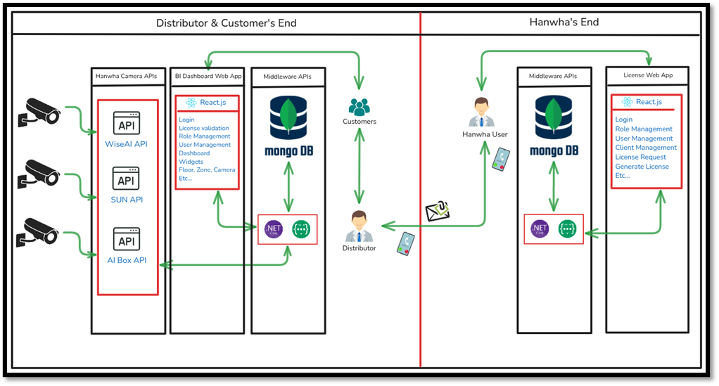

- The architecture below represents the flow of Backend Development Using .NET Core + Web API:

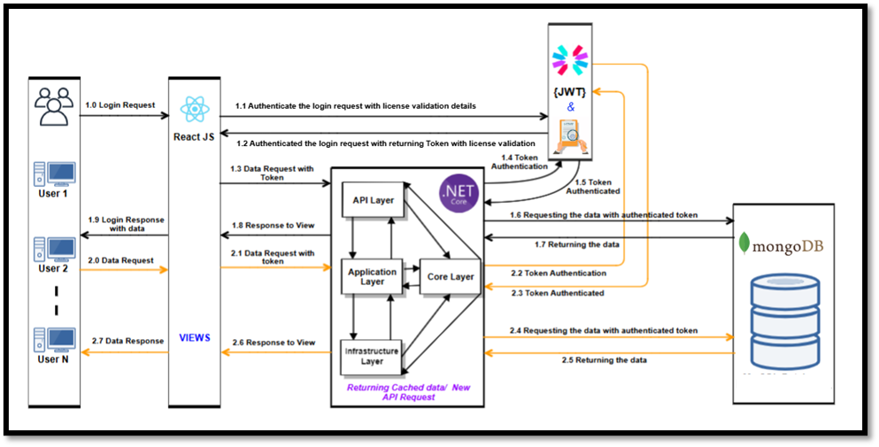
- The architecture below represents the flow of Frontend Development Using React.js Technology:

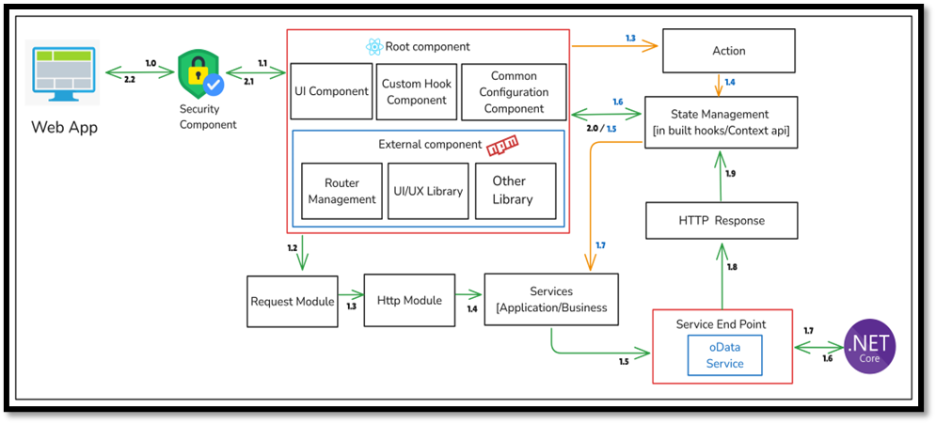

Project Plan

Process tailoring and Documentation Plan
- Refer SPECTRUM for more information

Project Schedule
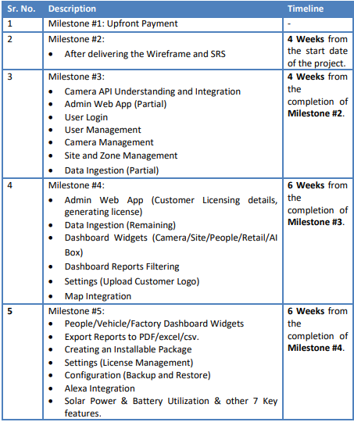

Resource Plan

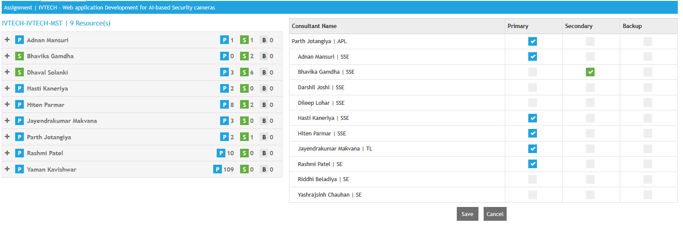

Roles and responsibilities

Sr No | Names | Role | Responsibilities
1 | Parth Jotangiya | Project Manager | SRS,Planning, Resource allocation, client communication, Invoicing, Weekly status update in SPECTRUM.
2 | Jayendrakumar Makvana | Sr. Software Developer | Requirement Analysis, Estimation, Coding, Unit testing, UAT, client communication
3 | Bhavika Rafaliya | Software Developer | Functionality developments, Estimation, Coding, Unit testing.
4 | Hasti Kaneriya | Software Developer | Functionality developments, Estimation, Coding, Unit testing.
5 | Hiten Parmar | Software Developer | Functionality developments, Estimation, Coding, Unit testing.
6 | Adnan Mansuri | Software Developer | Functionality developments, Estimation, Coding, Unit testing.
7 | Rashmi Patel | Software Developer | Functionality developments, Estimation, Coding, Unit testing.
8 | Dhaval Solanki | Designer | Apply UI changes

Resource allocation plan
- Refer - SPECTRUM5 (Project Code: IVTECH)

Resource Acquisition plan
NA

Training Plan
NA

Quality Assurance Plan
NA

Metric Plan
Metric | Units | Target for this project | Comments
Effort Variance | % | <=5%
Schedule variance | Days | <120 | Development of functionalities associated in SOW are in progress.
Total Test Effectiveness | % | >=20

Project Review Plan
NA

Test Plan
NA

Configuration Plan
      - Build Control
NA

      - Version Control

- Gitlab Path: https://gitrepo.specindia.com/root/IVTECH_IVTECH

      - Change Control
NA

Miscellaneous Plans

Risk Management Plan
https://gitrepo.specindia.com/root/ivtech_ivtech/-/tree/master/1.%20Document/2.%20ProjectManagement/Risk%20List

Communication Plan
Sr No | Internal Contact Details | Interfaces(Mails, Telephone,Chat etc) | External Contact Details
1 | parth.jotangiya@spec-india.com | Email | b.madiraju@hanwha.com

Status Reporting Plan

Sr No | Role of the Reporting Person {PM/PL/TL} | Formal/Informal | Frequency of Reporting {Monthly, weekly, Daily) | Reporting to(Role)/Name
1 | APL | Formal | Monthly | SPECTRUM5

Escalation plan

Internal Escalation

Sr No | Issue Type | Designations responsible in ascending order.
 |  | 1st Person | 2nd Person | 3rd Person | 4th Person
1 | Approval Delays | Parth Jotangiya | Yaman Kavishwar
2 | Delay in payment | Parth Jotangiya | Yaman Kavishwar
3
4

External Escalation

Sr No | Issue Type | Designations responsible in ascending order.
 |  | 1st Person | 2nd Person | 3rd Person | 4th Person
1 | Approval Delays | Bala Madiraju | Prateek
2 | Delay in payment | Bala Madiraju | Prateek
3

Customer Supplied Products (If applicable)
NA

Back Up plan
S. No. | Type of Back Up | Person Responsible | Frequency  {Daily/Weekly/Monthly} | Medium
 | GitLab Backup | Ankit Patel

Close out Plan
Customer feedback has been received from the client.

